**Benjamin (BJ)**

**Page 1:**

Disable / enable text tip (text will appear or disappear if needed)

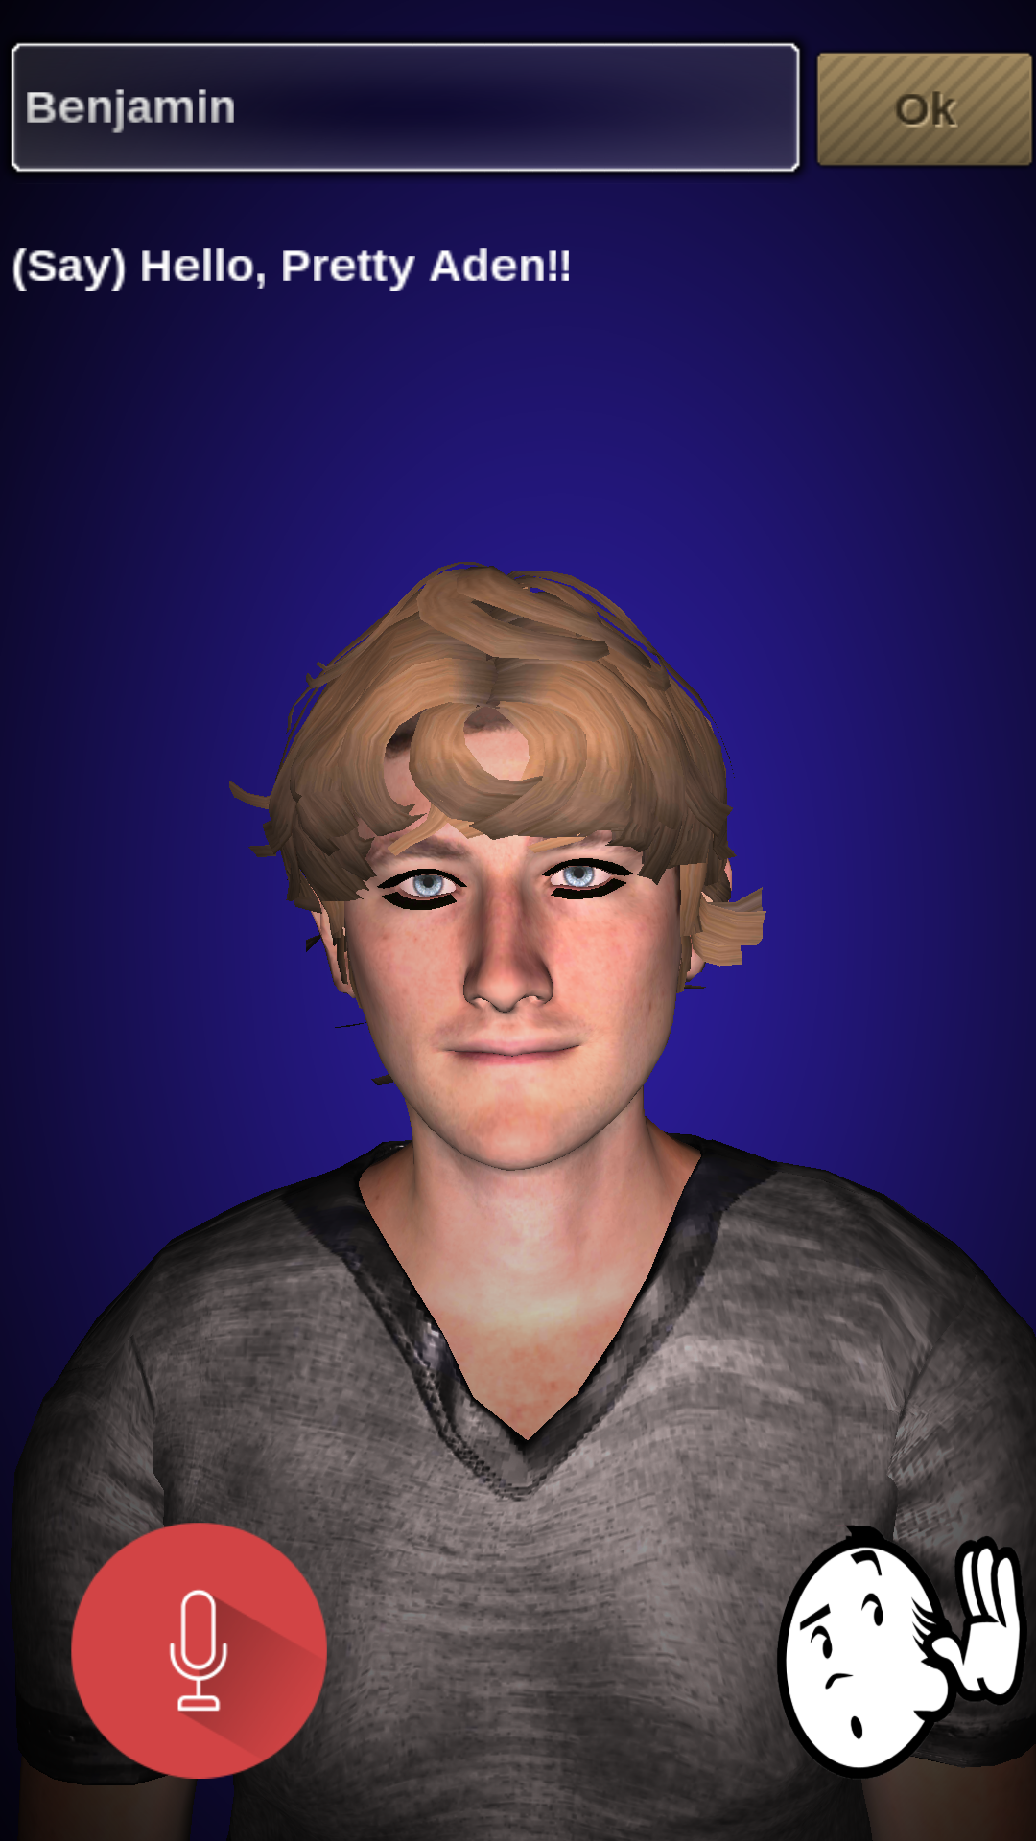

This page will display following the launch

Use an info (i) icon to display the animation explaining how to use the app

Library (setting page):

In this page we set emergency phone number. Benjamin is asking these questions and the user voice response will be saved.

What is your name? What is your tel number?

Call emergency:

User says “Call Emergency”, then Benjamin will dial the number (add animation – BJ: Ok I am calling your emergency now …)

2- PainTracker Page

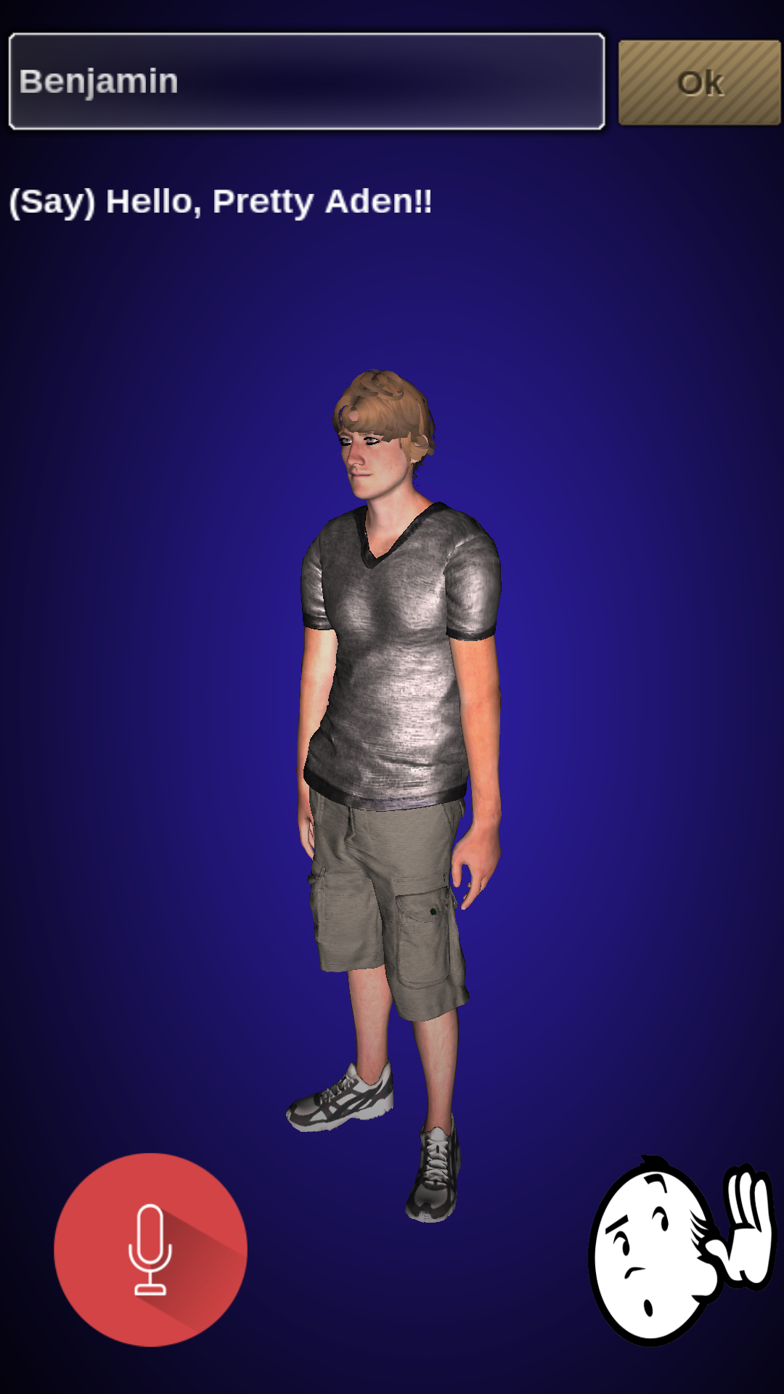

1. User voice “Not Feeling Well”
2. The screen will change and BJ is asking “What can I do for you”
3. User: “Headache”

Screen will focus on the head part and user can rotate the image

1. BJ: “Touch the area and tell me How sever is your pain from 1 to 10?”
2. User: “6”
3. BJ: “Ok , Logged, anything else?”
4. User: “ No” then the screen will move back to the main page

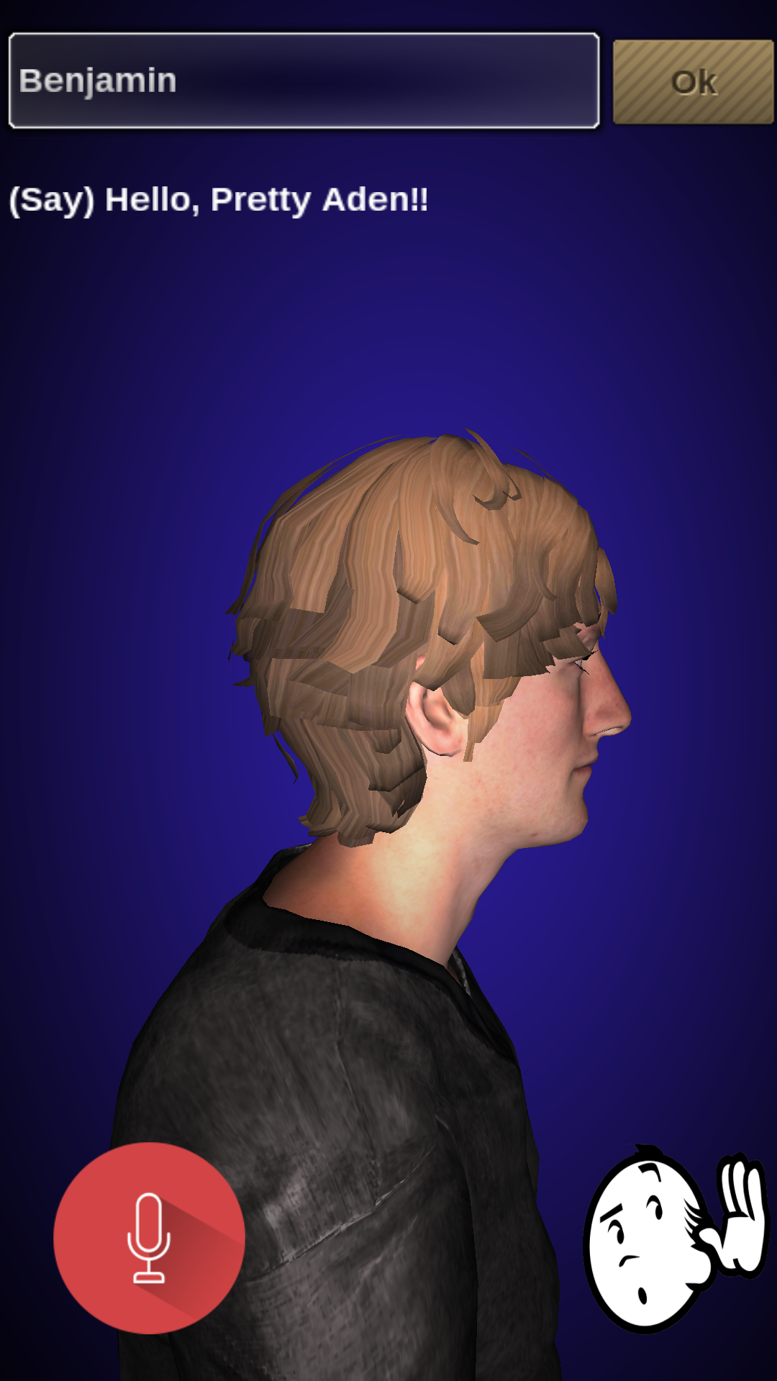

3- Info Page

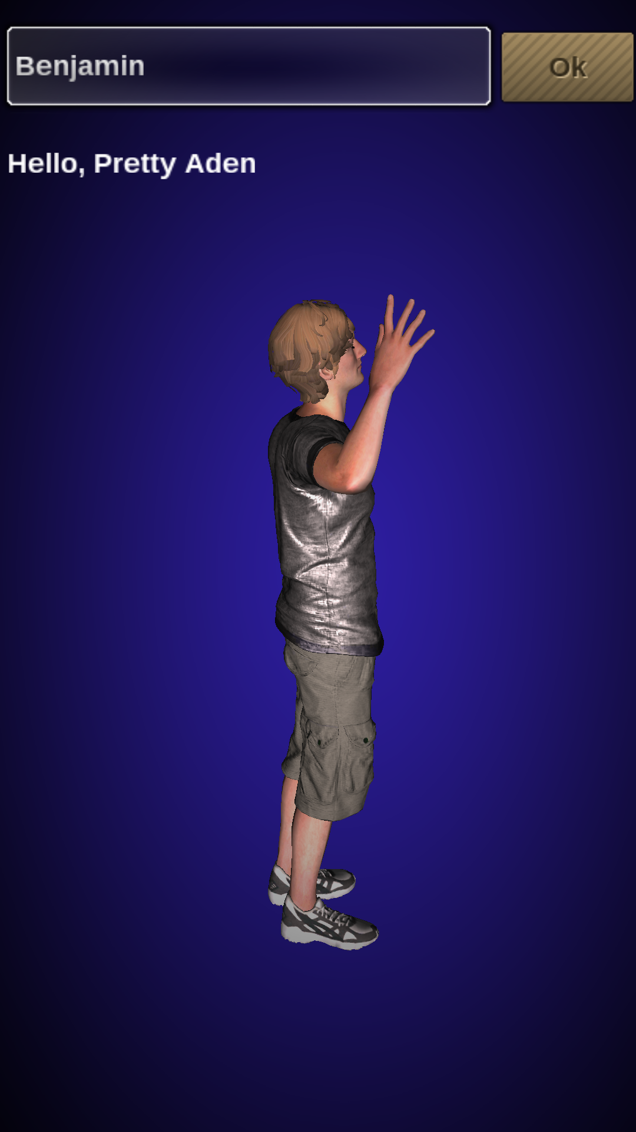

This page BJ will talk to user describing how to use the application